|  |  |
| --- | --- |
| NAME | REG NO : |
| VIVEK.S | 812919106028 |
| AADHIDEVAN.P | 812919106001 |
| KAVYA.D | 812919106007 |
| SABITHA.S | 812919106018 |

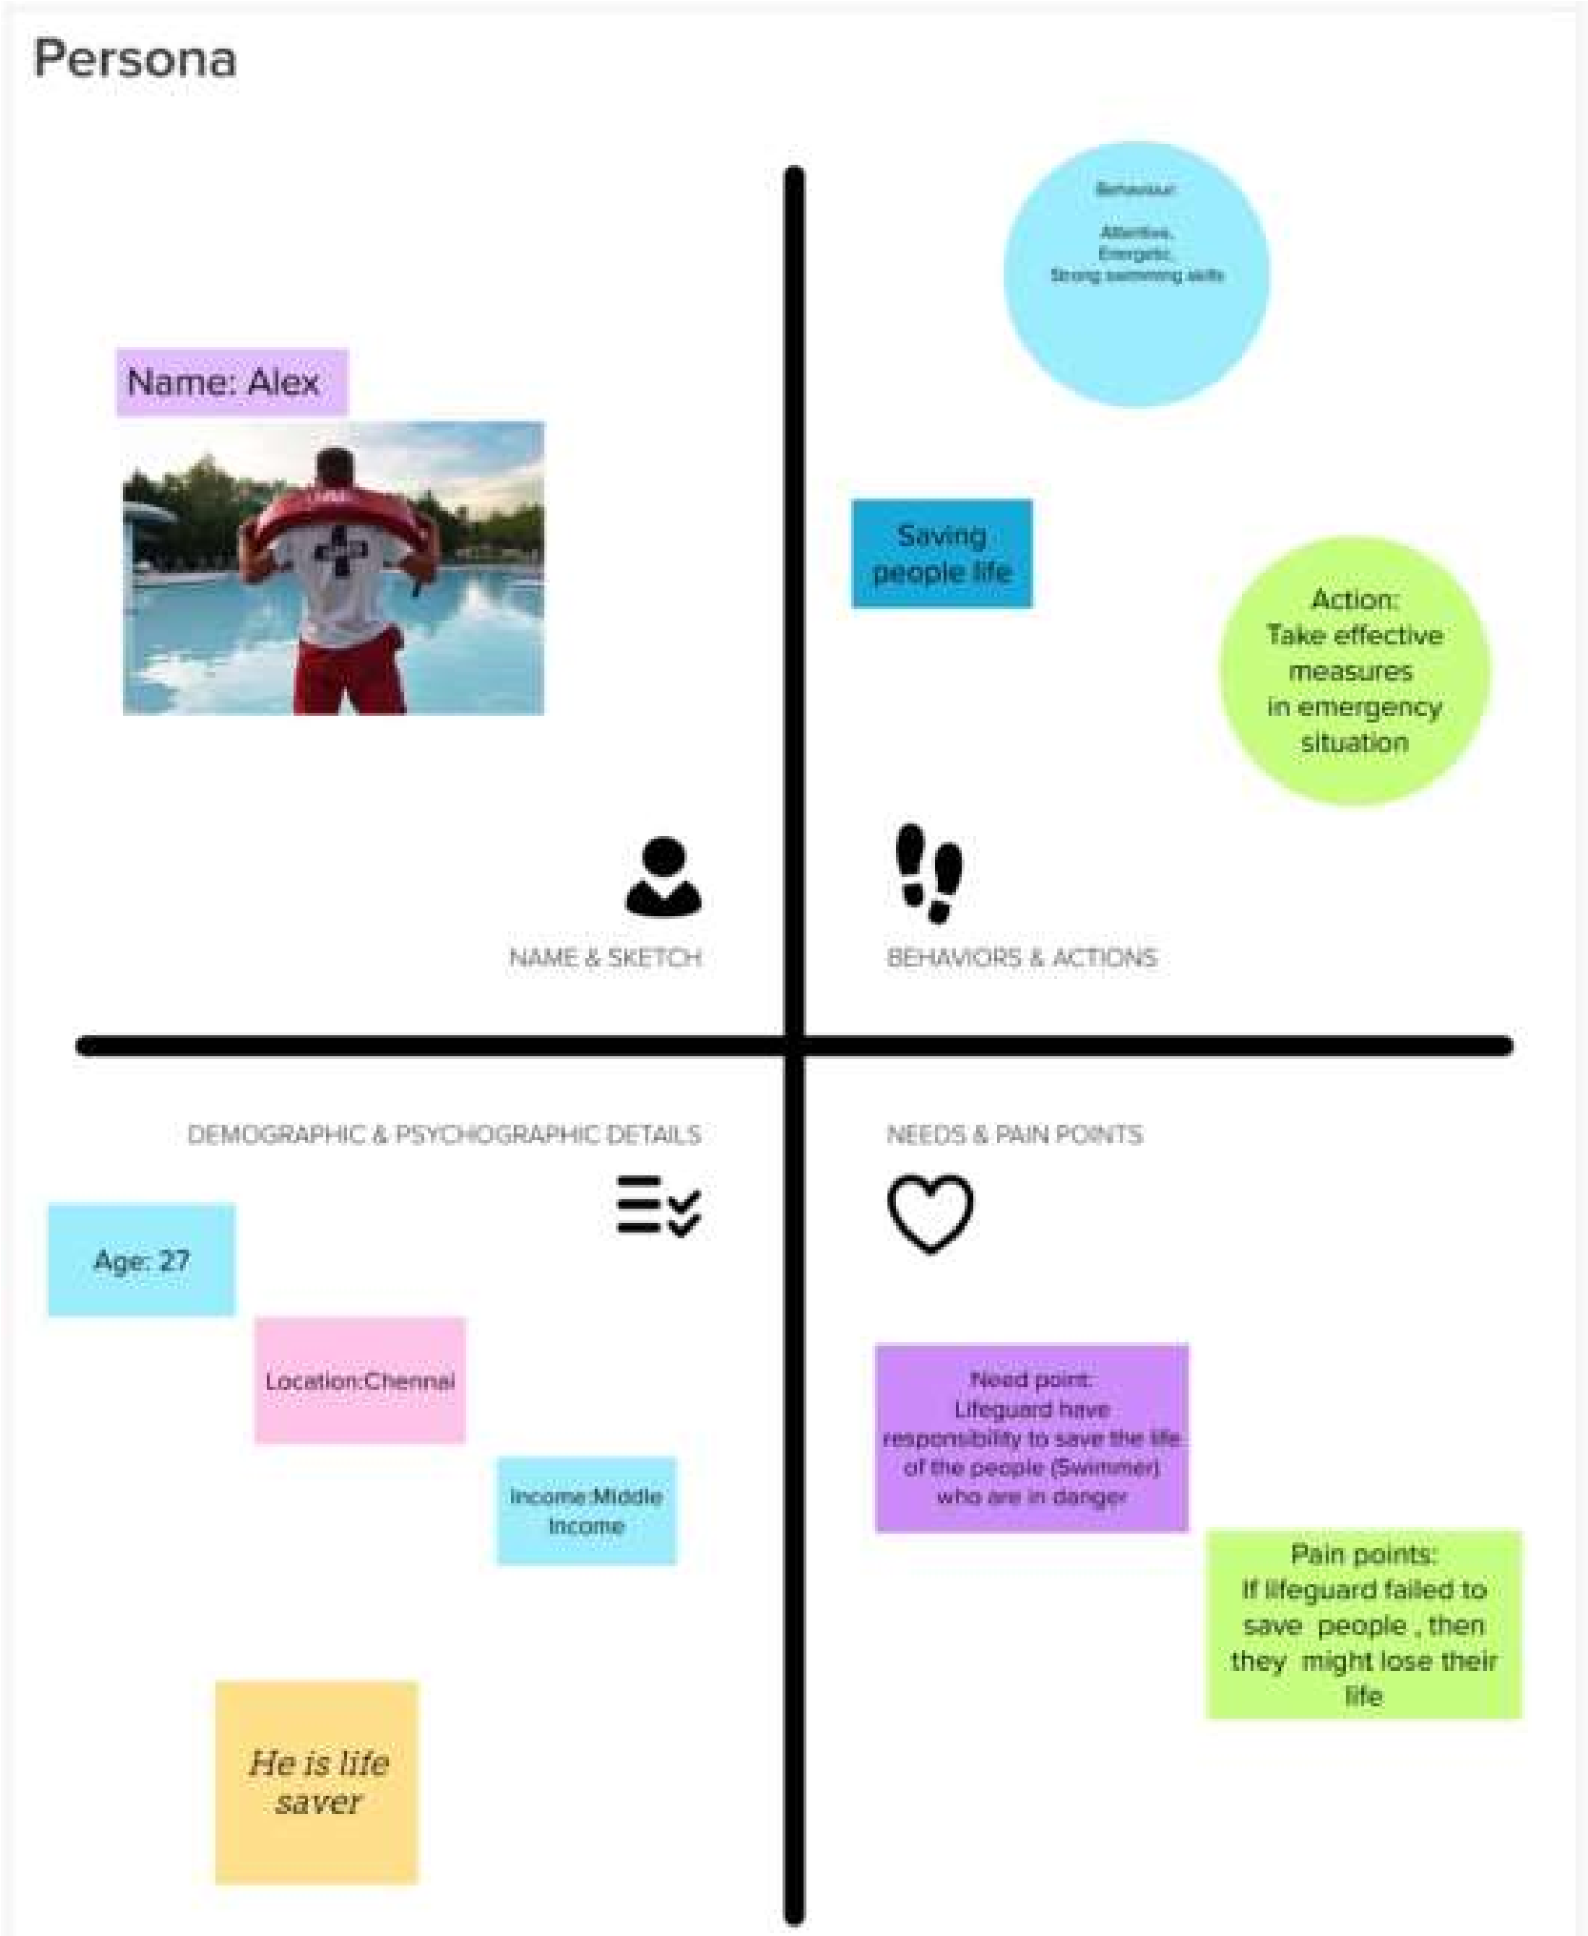

**Virtual eye - Lifeguard for swimming pool to detect active drowning**

Safety in swimming pools is a crucial issue. In this a real time drowning detection method based on HSV colour space analysis is presented which uses prior knowledge of the video sequences to set the best values for the colour channel